4/18

* Talked about tightly coupled Student and Classroom objects: students have schedule, vaccination status, and a “nearby” method that acts as a distance formula.
* Classroom objects include list of students, risk category, and 2d array of positions
  + As of now, setting array to ridiculously large value (~1000) so don’t have to worry at all about classroom size
* Choice to use linked list for general use, instead of having arrays of objects
* Website → Started thinking about how to incorporate the form link into our website. revisited learning basic HTML to understand how to create our website.

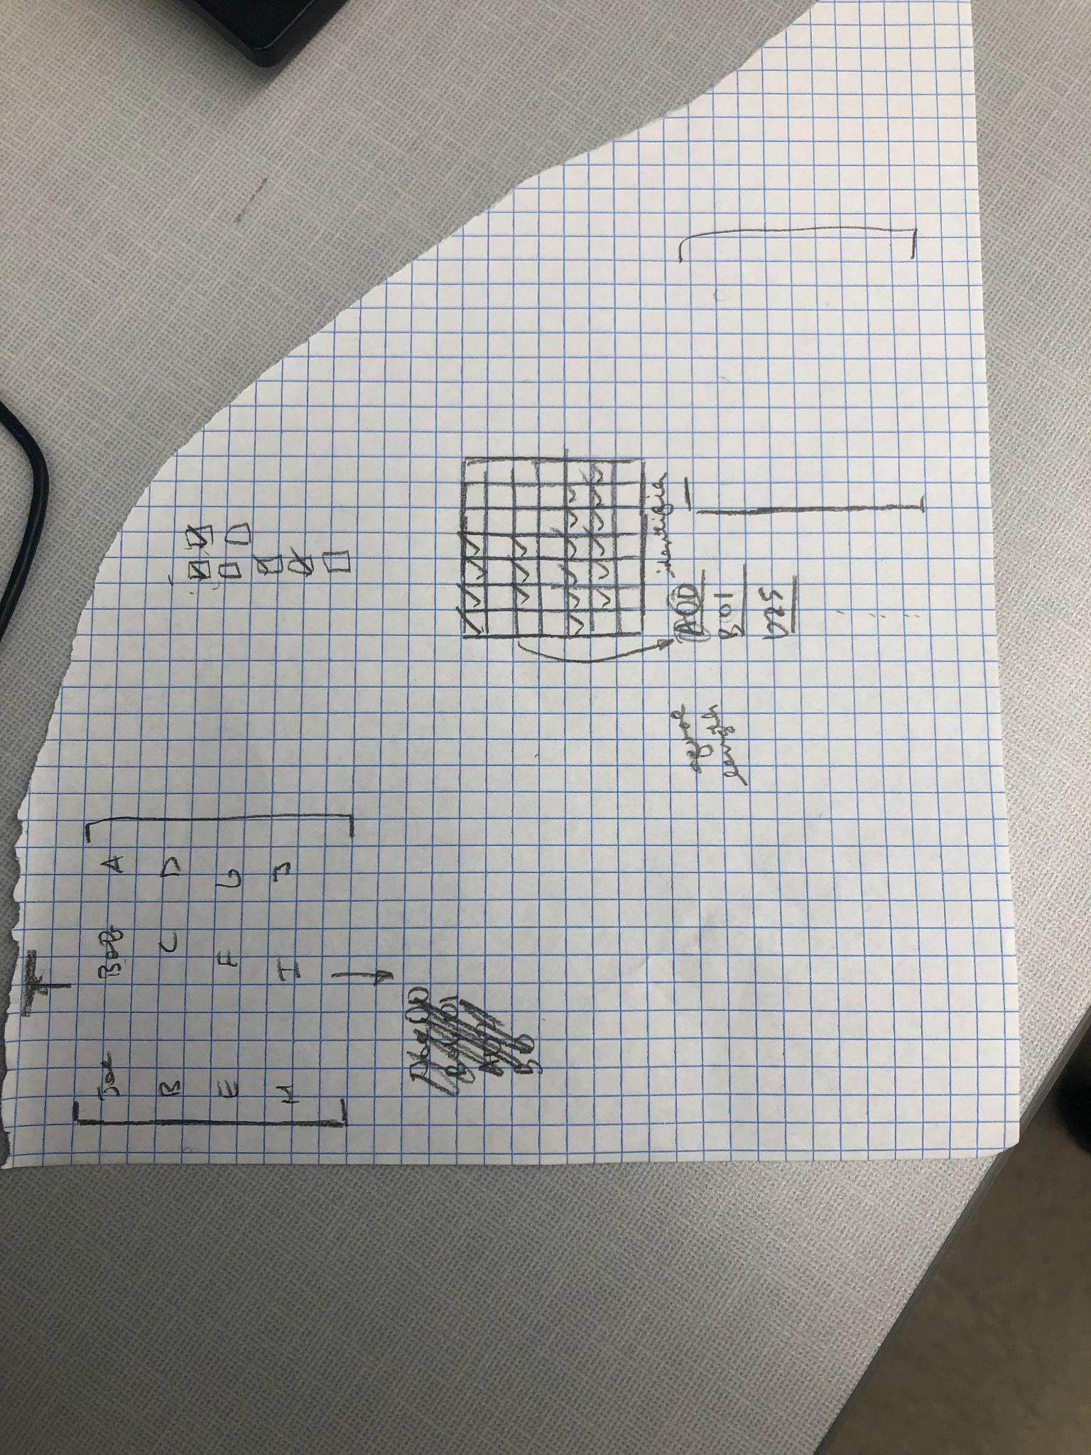

4/20

* Tested adding and getting in linked list implementation of classroom
  + Had to create pointer when declaring object and dereference the object when passing into methods
* Also tested linked list code (which was created by Nathan)
* Added classroom name for identification of class